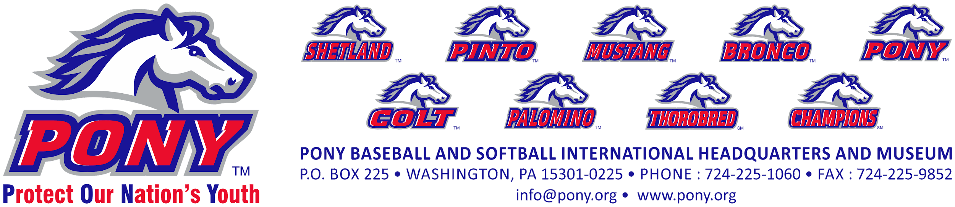
PONY Baseball and Softball is proud to announce an Alumni Scholarship for graduates of PONY. In order to be considered for a scholarship a PONY baseball or softball player must have played in a PONY affiliated league and must be a senior in high school. Likewise an application must be submitted prior to May 1st of the current year along with the School & Community Activities Form, an Essay on the designated topic, an Official Secondary School Transcript, test results from either the SAT, ACT or TOEFL, a copy of the Letter of Acceptance from the school you are planning to attend, a Notarized Letter confirming participation in an affiliated league and two Letters of Recommendation.

When the aforementioned information has been received, the Scholarship Committee will consider the application complete.

The Scholarship Committee will administer eight scholarships annually, one each to the four United States Zones (North, East, South, and West), Asia Pacific Zone, Caribbean Zone, Canada and Mexico.

Abraham Key
President and CEO
PONY Baseball and Softball

(Scholarship form is following 4 pages of document)

PONY BASEBALL AND SOFTBALL
ALUMNI SCHOLARSHIP
INFORMATION

PONY is proud to offer a scholarship to alumni of the PONY Baseball and Softball program. To qualify and to be considered each applicant must submit the following:
- The Application for the scholarship signed and dated by both the applicant and their High School Guidance Counselor.
- The School & Community Activities Form.
- The Essay (100 words or less).
- An Official Secondary School Transcript.
- Test results from either the SAT, ACT or TOEFL.
- A copy of the Letter of Acceptance from the school you are planning to attend.
- A Notarized Letter from the League President of the PONY affiliated Baseball or Softball League confirming the applicant’s participation for a minimum of two years in the league.
- Two Letters of Recommendation.

Guidelines:
- All information must be neat and legible. (Fill out in Microsoft Word, print and sign)
- Send the application materials via CERTIFIED MAIL no later than May 1st of the current year.

PONY BASEBALL AND SOFTBALL, INC.
ATTN: SCHOLARSHIP COMMITTEE
P.O. BOX 225
WASHINGTON, PA 15301

ALUMNI SCHOLARSHIP
APPLICATION

STUDENT’S NAME:

STUDENT’S HOME ADDRESS
(Street):
(City):
(State, Zip):

STUDENT’S HOME TELEPHONE NUMBER:

E-MAIL ADDRESS:

HIGH SCHOOL NAME:
HIGH SCHOOL ADDRESS
(Street):
(City):
(State, Zip):

HIGH SCHOOL GUIDANCE OFFICE TELEPHONE NUMBER:
HIGH SCHOOL GUIDANCE COUNSELOR NAME:

APPLICANT’S CLASS RANK:
APPLICANT’S ACT, SAT or TOEFL:
AREA OF CONCENTRATION/STUDY:
COLLEGE, UNIVERSITY OR TECHNICAL SCHOOL APPLICANT PLANS TO ATTEND

STUDENT’S SIGNATURE:
DATE:
GUIDANCE COUNSELOR’S SIGNATURE:
DATE:

ALUMNI SCHOLARSHIP
SCHOOL AND COMMUNITY ACTIVITIES
FORM

STUDENT’S NAME
HIGH SCHOOL
Please list in the order shown below, all school, community and PONY Baseball or Softball activities you have been involved with since the ninth (9th) grade. List any leadership roles you have held and any special honors you have achieved. (If additional space is necessary, please use the back of this form)

GRADE 9:

GRADE 10:

GRADE 11:

GRADE 12:
ALUMNI SCHOLARSHIP
ESSAY

In 100 words or less, please respond to the following:

PONY is an acronym for Protect Our Nation’s Youth.

What value has the meaning of this acronym had on your personal growth and development?

